EXERCISE-31

31.Design PDA using simulator to accept the input string anbn

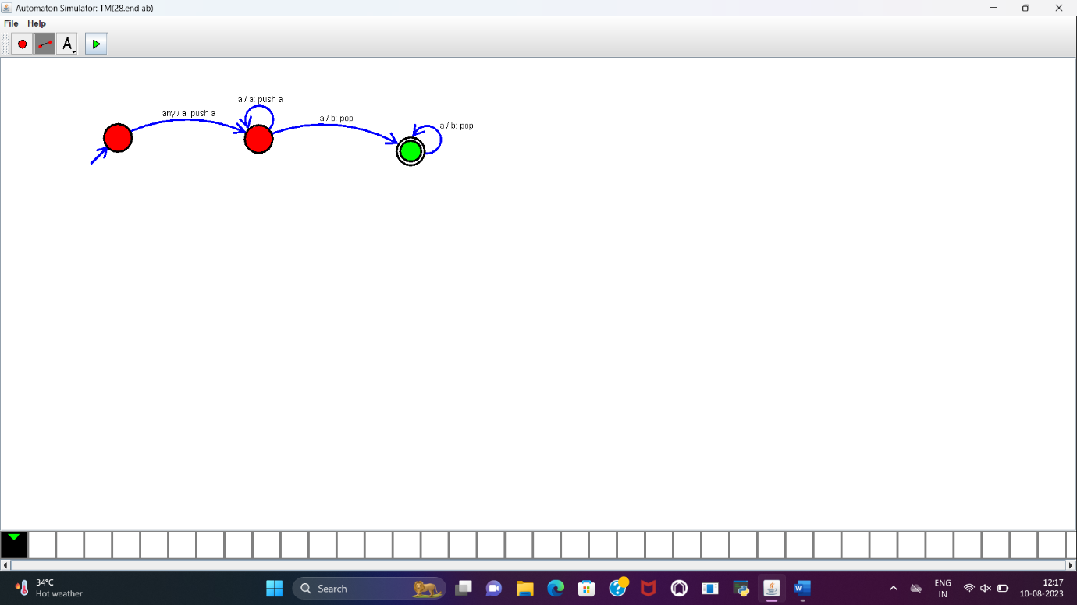

RESULT:

PDA to accept the input string a^nb^n is designed and implemented successfully using simulator.